Wedding Invitation
You are Invited to our Wedding Ceremony, Please describe the event briefly here

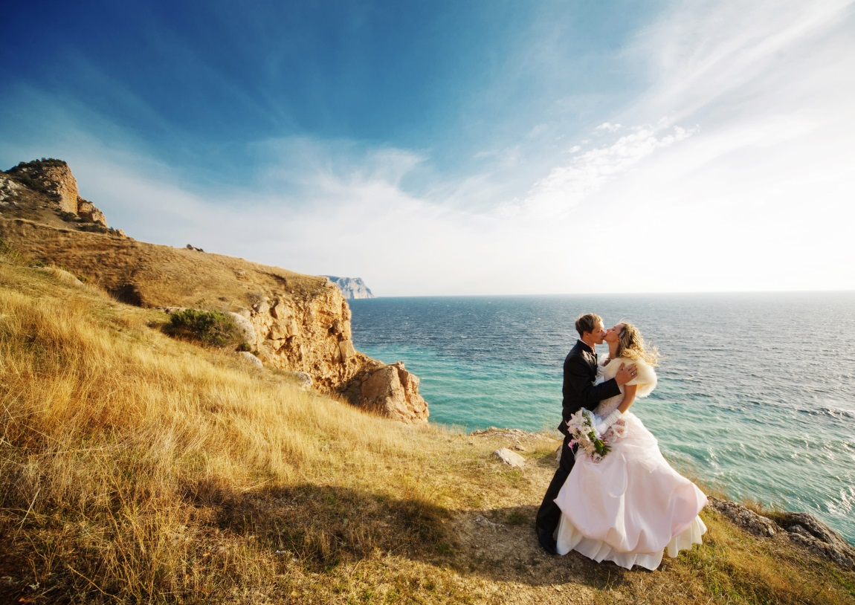

YOUNG WON
and
SA RANG

March 17, 2017 Sunday at 3pm

ARTS INCUBATOR EVENT LOFT
115W 18th Street Kansas City, Missouri

